**Overall Application**

Application will run on Windows 7 computer (64 bit OS)

* Cloud-based solution – Based on Tomcat / MySQL / Smart-GWT.
* Create a local installer for windows to install and setup and configure the software so it can run stand-alone on a PC.

Ability to customize the app to add in company logo.

**Capabilities of this application**

**Account Management**

* A user can subscribe to be a user of the application
  + Includes a credit-card for monthly billing.
* A user can customize the application by entering their company logo
* A user can create user accounts
  + User account has a login name, password, email address, and access type
  + Access type limits which screens a user has access to.
* A user can assign access to capabilities on a per-account basis.

**The user will be able to maintain an inventory of ingredients**

* An ingredient has the following information associated with it.
  + Supplier
  + Ingredient Name (The combination of Ingredient Name and Supplier must be unique)
  + Delivery Unit (Box / Bag etc) (Delivery Units are Unique)
  + Quantity per Delivery Unit (Lb, Oz, Kg etc) (Delivery Units are Unique
  + Price per Delivery Unit (Must be >=$0)
  + Ingredient Type (Grain, Adjunct, Yeast, Hops or Spice)
* The following Supplier Information may be entered:
  + Name, Address, Phone, Fax, Email, Website.
* The user can sort / filter ingredients based on supplier, type, cost, alpha-numeric etc.
* The user can view the entered ingredients and then manage them (edit, update, filter, delete, etc).
  + When an ingredient is deleted then the user has the option to define a substitute ingredient for the recipes that used the ingredient.
* The user can add / delete / update ingredients.

**The user will be able to enter production costs (labor, energy and water)**

* For Labor the following information can be captured
  + Employee Name
  + Hourly Rate
  + Add Employee / Delete Employee
  + What is the behavior when no Employees are available?
* For Energy the following information can be captured
  + Electricity is captured in cost per KWH
  + Natural Gas is captured in cost per therm
  + Water is captured in cost per HCF (Hundreds of Cubic Feet)
  + What is the behavior when no energy cost information is available?

**The user will be able to create recipes from ingredients**

* A Recipe is a set of raw goods and a set of production costs
* Each recipe has metadata.
  + Metadata includes recipe name,
  + Recipe type (Ale / Lager)
  + Recipe Style (from BJCP Style List)
  + When last brewed
* The user selects ingredients to include into the recipe and the quantity of each ingredient to include.
* The production costs associated with a recipe are based on the labor hours, energy (Natural Gas / Electricity) and water used.
* Recipes are named and a user can assign 0 or more items from each ingredient type and quantity for a recipe.
* A user will be able to ingest a recipe from Promash and perhaps other recipe designer software.
* A user can print a Recipe Information as a PDF form.
* A User can create, delete, update or save-as recipes.

**The user will be able to plan a brewing cycle.**

* A Brewing cycle is where the user selects a set of recipes to brew.
* For each recipe within a brewing cycle the user will specify how much beer will be brewed.
* The user will be able to determine the amount of ingredients required for a brewing cycle.
  + The Ingredients needed for a brewing cycle is defined by the selected recipes and planned quantity for a brewing cycle.
* For each recipe selected for a brewing cycle the user will assign the staff that will be brewing the beer.

**The user will be able to determine the cost of goods**

* Cost of Goods behaves in two different modes, a “What-if” Mode and a cost per brewing cycle mode.
* When computing costs per brewing cycle the application will display COGS information for each of the selected recipes and selected amounts.
* When computer in a “What if” Mode a user selects a recipe and a quantity. The Application will compute COGS based on the scenario.
* Ability to generate the TTB reports for produced specific production of a beer recipe.

**Leila and John’s Notes**

When user opens application, the Ingredients tab is shown.

**Ingredients Tab**

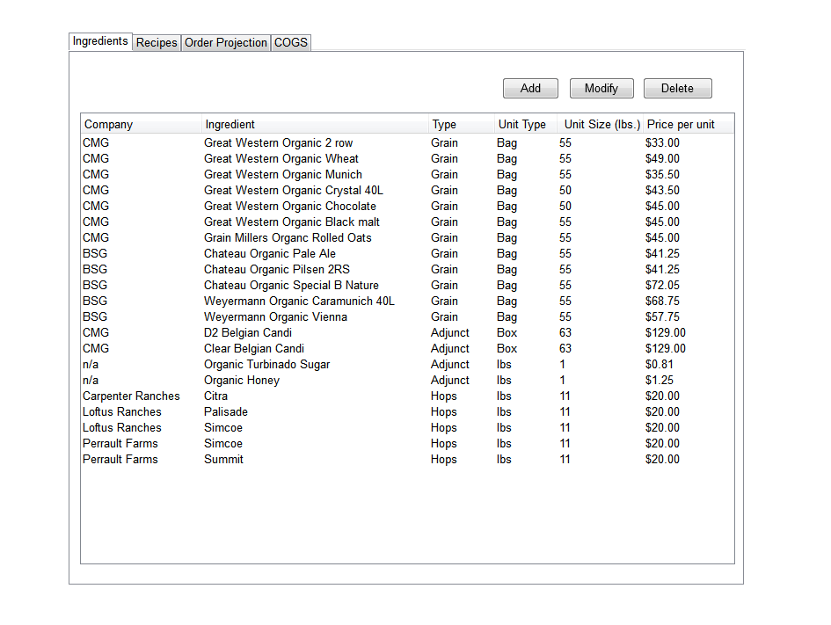

MULTI-SELECT FOR DELETE

NO MULTI-SELECT FOR ADD

NO MULTI-SELECT FOR MODIFY

NEED AN ABILITY TO CREATE COMPANY

NEED AN ABILITY TO CREATE TYPE (Current set is Grain, Adjunct, Hops, Spice, Yeast)

NEED AN AB ILITY TO CREATE A UNIT TYPE (Current set is Bag / Box / LBS)

Unit Type is the size that the shipper sends the stuff to you in

Unit Size is the mass that the ingredient is sent (on a per box / bag / whatever) basis. Measured in either lbs or kgs.

Price per unit is the price per unit type.

User has the ability to sort alphabetically ascending and descending by each column.

The default sort is by Company and then by Ingredient.

If the user selects the Type or Unit Type column headers to sort, the secondary and third sort order is by Company and then Ingredient.

If the user selects the Unit Size, Price per unit, or Ingredient column header to sort, there is no secondary or third sort order.

The table will have a scroll bar to the right to allow the user to scroll up/down.

The Add button is always active.

The Modify button is greyed out until user selects one row of information.

The Delete button is greyed out until user selects one or more rows of information using the Shift or CTRL buttons.

To add an ingredient, the user selects the Add button, and the Add Ingredient window appears.

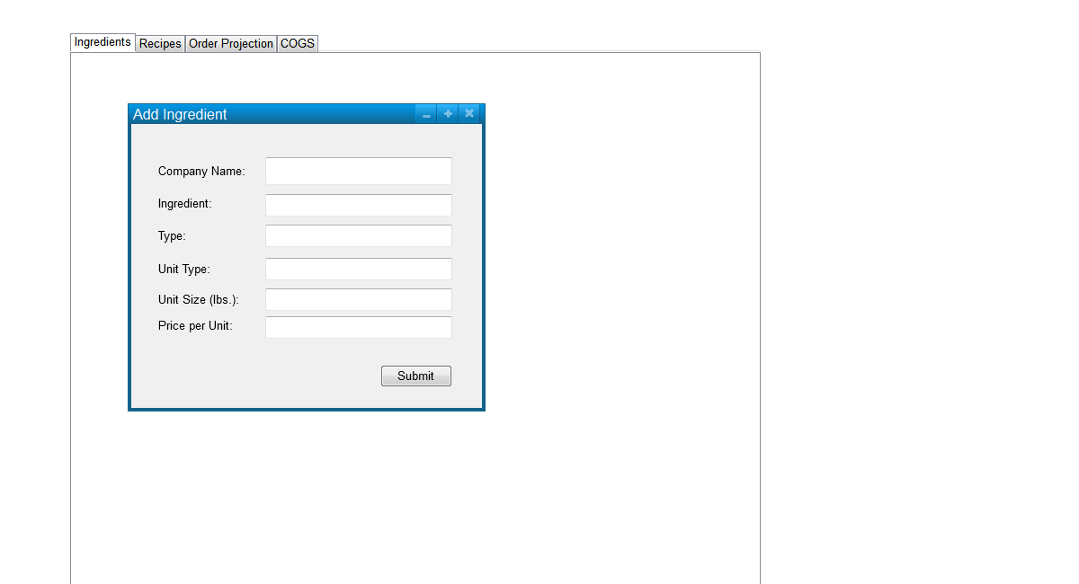

COMPANY NAME IS A PICK-LIST. YOU CAN ADD A COMPANY FROM THIS DIALOG

INGREDIENT IS A TYPED IN FIELD

FOR COMPANIES MANAGE COMPANY NAME, CONTACT NAME (S), EMAIL, FAX, PHONE, ADDRESS, WEBSITE ETC.

TYPE IS A PICK-LIST, YOU CAN ADD A NEW TYPE FROM HERE (Yeast, Spices, Adjuncts, Hops and Grain)

UNIT TYPE IS A PICK-LIST, YOU CAN ADD A NEW TYPE FROM HERE

UNIT SIZE IS A PICK-LIST, YOU CAN ADD A NEW UNIT SIZE FROM HERE.

PRICE PER UNIT IS A TYPED IN FIELD.

The Company Name will auto-complete based on information in the database file.

The Submit button will save the information to the database file and will automatically update the Ingredients tab contents.

VALIDATION CHECK: No duplicate Ingredient names are allowed. (THIS COMBINATION IS THE INGREDIENT NAME AND SUPPLIER), PRICE PER UNIT MUST BE >= $0, UNIT SIZE MUST BE >0,

TYPE NAMES MUST BE UNIQUE

COMPANY NAMES ARE UNIQUE

UNIT TYPE IS UNIQUE

UNIT SIZE IS UNIQUE

The user has the ability to modify an ingredient after selecting one row in the Ingredients table and selecting the Modify button.

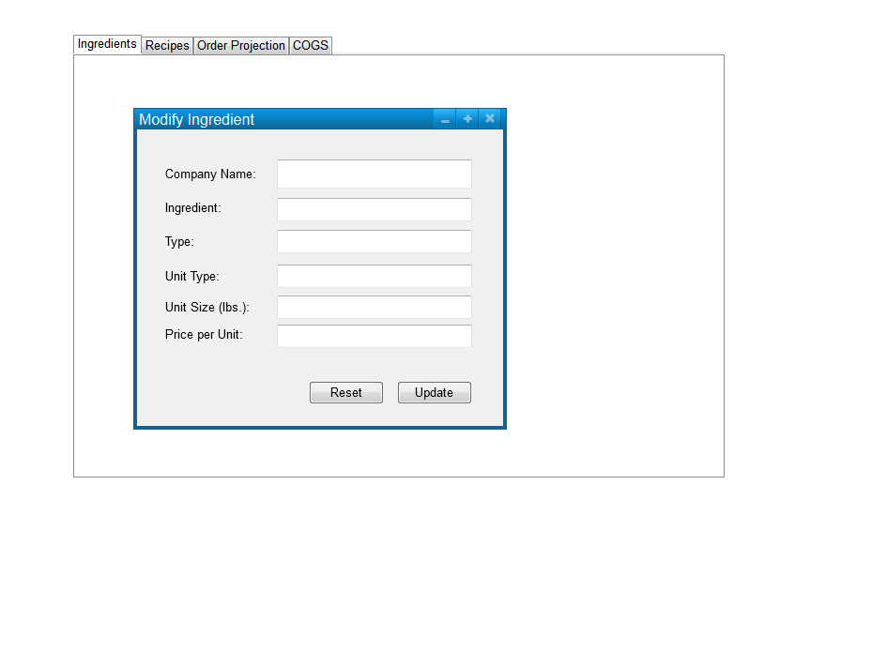

Modify Ingredient window is pre-populated with the information from the selected row in the Ingredients table.

The Update button will save the information to the database file and will automatically update the Ingredients tab contents.

The Reset button will reset the fields to the information in the database file for the selected ingredient.

**Recipes Tab**

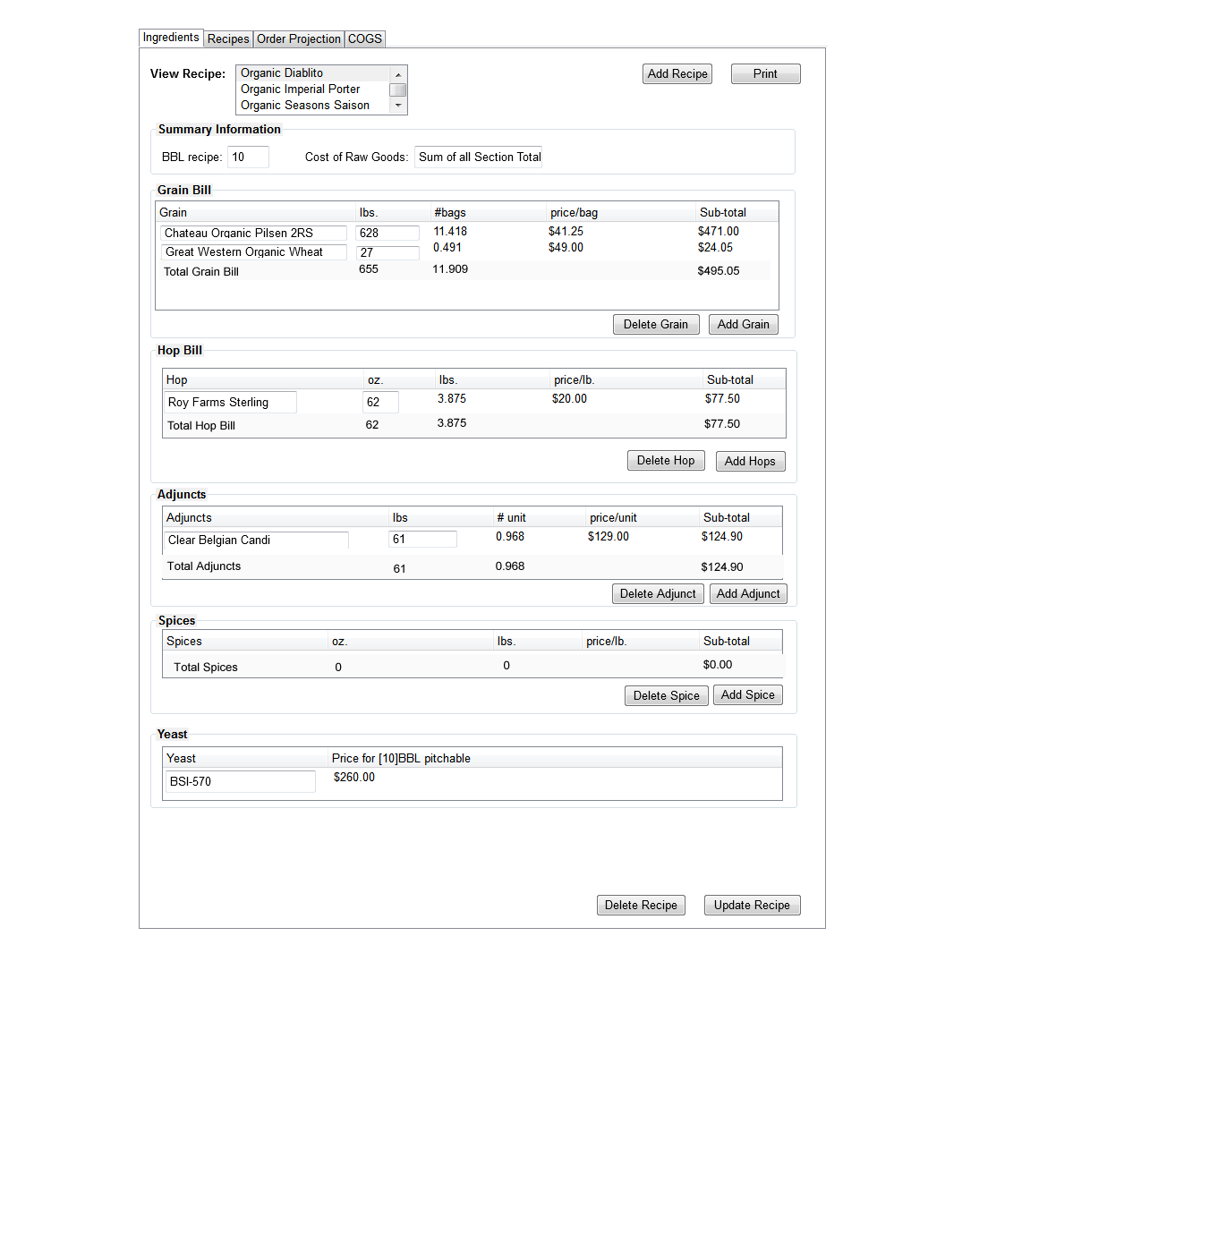

1 Section per ingredient type.

For each recipe the ability to save, save-as, refresh from database.

The Recipes tab is white (not grey as in above graphic) to show it is active.

For each recipe section, define the ingredient type, the units are fixed (oz, lbs etc) and then the # of units are needed for each ingredient, then compute the sub-total based on the quantity x price per lb, to get the sub-total.

For each recipe add two minor tabs, the primary minor tab is to capture the raw goods cost, and the secondary tab will capture the production costs – that is the Hours and Gas and Water for making beer.

CRUD functionality for recipes.

FOR Creating a new Recipe – Recipe names need to be unique

Add a Recipe Search capability – Type in name and let it search, the set of recipes.

Same capabilities for the Ingredients definition page as well.

Have some Beer Metadata – Type (Ale / Lager) and Style (BJCP Style list) – with sub-sets to styles. Also track when the recipe was last used / brewed.

Consider an ability to import a recipe from ProMash or other software systems. Then the ability to link up the beer ingredients from Pro-Mash to the ingredients managed in this software.

The Ingredients tab is grey to show it’s inactive.

User may print the contents of the screen to printer or Adobe PDF by selecting the Print button.

The View Recipe list is pre-populated from the database file.

When the user selects a recipe from the View Recipe list, the information in each section is pre-populated from the recipe file.

Each section’s information is displayed as a descending sort by the amount (lbs or oz) column.

The user may modify the recipe by adding ingredients to each section, or by modifying ingredient names and quantities.

If the user modifies an existing ingredient name, the field will autocomplete from the database file.

The ingredient name must be in the database file to be valid.

The user may select an ingredient in each section and delete it by selecting the ““Delete X” button (i.e., Delete Grain). Only one ingredient may be deleted at a time.

To add an ingredient to a section, the user selects the “Add X” button (i.e., Add Grain). A new line appears at the top of the section’s table and the user may enter the name and quantity. The rest of the information populates based upon the information entered by the user.

The ingredient name field will autocomplete from the database file. The ingredient must be in the database file.

If the user selects the Delete Recipe button, a pop up message appears asking them to confirm the deletion.

The message is: You wish to Delete the recipe for {Recipe Name}. This action cannot be undone. Are you sure you want to delete this recipe?

The window has a Yes and No button.

If the user selects Yes, the recipe is deleted from the database file.

If the user selects No, the user is returned to the Recipe window.

The user may save updates to the recipe by selecting the Update Recipe button which causes a pop-up window to appear asking them if the recipe should be renamed.

The message is: Confirm update of existing recipe.

The window shows the current name of the recipe, and gives the option for the user to change the name.

The window has a Save and Cancel button.

If the user selects Cancel, the user is returned to the Recipe window.

If the user selects Save, the recipe information and name are updated/saved in the database file, and the recipe’s updated information is re-displayed in the tab’s content window. Each section’s information is displayed as a descending sort by the amount (lbs or oz) column.

User may add a recipe by selecting the Add Recipe Button.

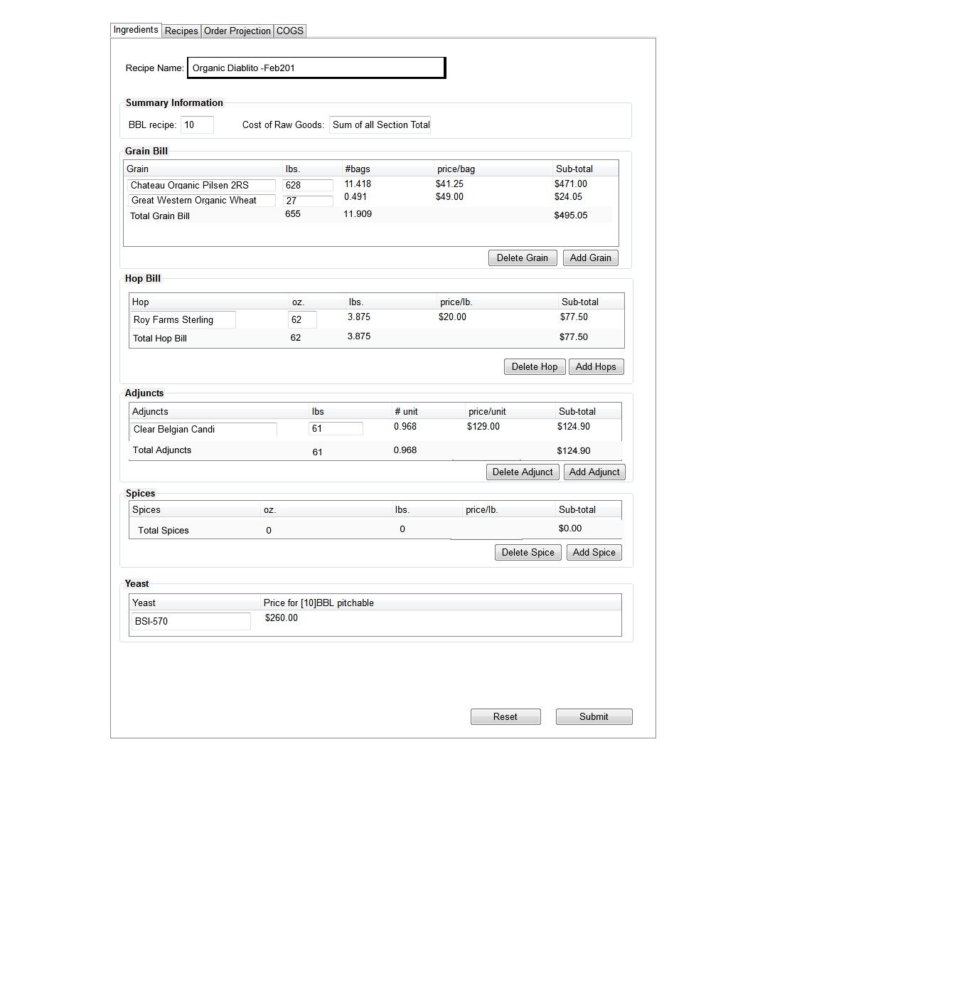

The Recipes tab is white (not grey as in above graphic) to show it is active.

The Ingredients tab is grey to show it’s inactive.

The user may enter the recipe name.

To add an ingredient to a section, the user selects the “Add X” button (i.e., Add Grain). A new line appears at the top of the section’s table and the user may enter the name and quantity. The rest of the information populates based upon the information entered by the user.

The user may select an ingredient in each section and delete it by selecting the ““Delete X” button (i.e., Delete Grain). Only one ingredient may be deleted at a time.

If the user selects the Reset button, the form is cleared of all information. All ingredients are removed from their sub-sections, and all other fields are blanked.

The user may save the recipe by selecting the Submit button, which causes the recipe information to be saved in the database file. The user then sees the recipe in the Recipe tab, and each section’s information is displayed as a descending sort by the amount (lbs or oz) column.

VALIDATION CHECKS: Recipe Name field is required.

**Order Projection Tab**

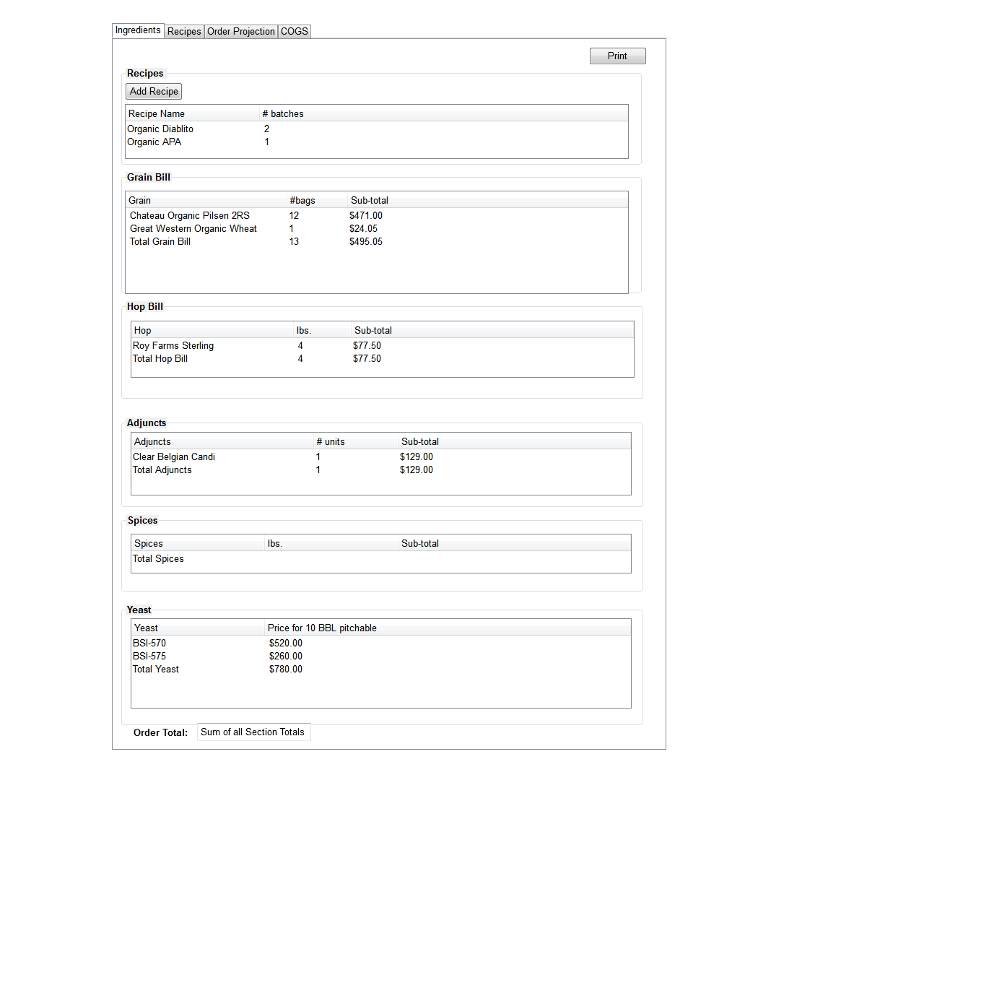

Brew Cycle has multiple batches.

The brewing cycle is – brew this week with supplies that I have on hand, I am waiting this week for the supplies that I ordered last week, and I am ordering supplies this week for the a beer I will make in 2 weeks.

An Event is a batch of beer. An order is composed of multiple events. This system is an order-centric system for forecasting beer brewing.

Ability to page through past and future brew cycles is a nice-to-have.

The Order Projection tab is white (not grey as in above graphic) to show it is active.

The Ingredients tab is grey to show it’s inactive.

This window opens with each section showing 0’s in the section totals and no ingredients listed. The user must add recipes to populate this tab’s contents.

User may print the contents of the screen to printer or Adobe PDF by selecting the Print button.

Order Projection values are all calculated. See Brewery Software Variables.xlsx for this information.

The user adds recipes by selecting the Add Recipe button, which displays a pop up window.

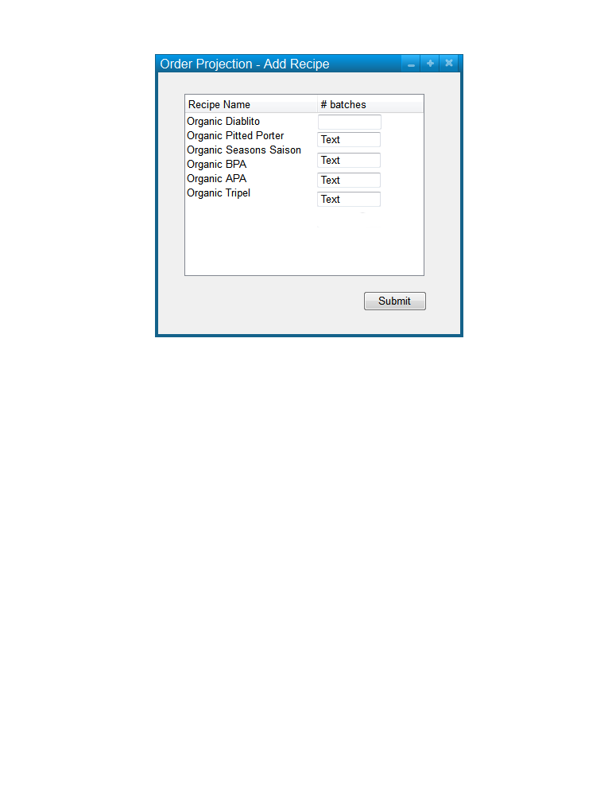

The list of recipes are pre-populated from the database file.

The user can enter the number of batches for each recipe.

When the user selects the Submit button, those recipes with values in the # batches column are added to the Order Projection tab contents.

**COGS Tab**

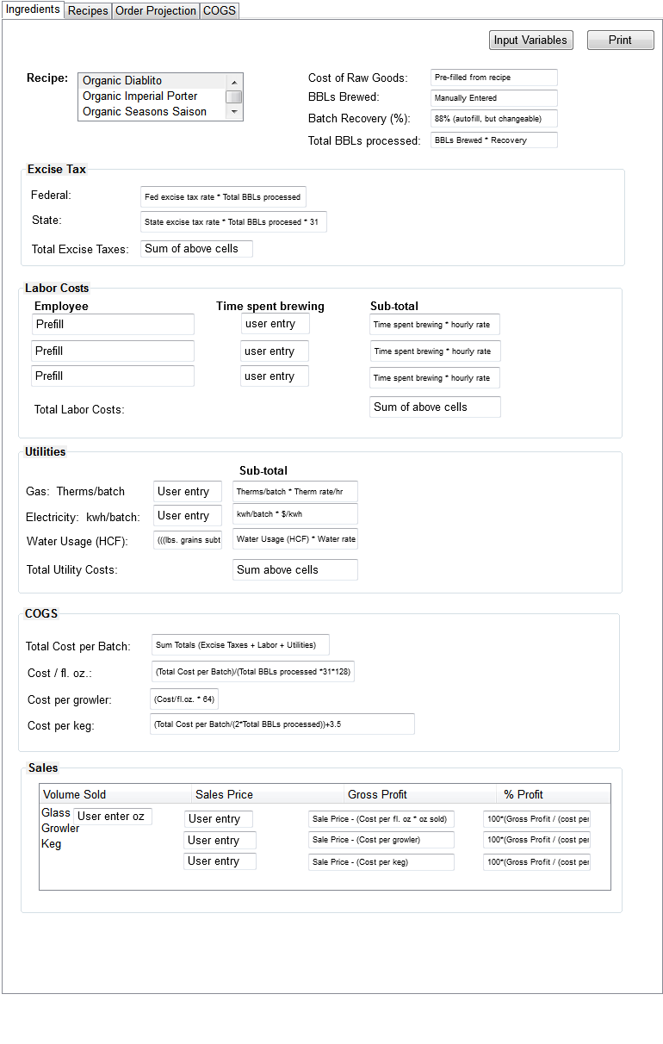

The COGS tab is white (not grey as in above graphic) to show it is active.

The Utilities and Labor costs are migrated to the recipe sub-tab.

There is also a contracts tab that shows the labor costs ($/hour/employee) and the energy and water costs per HCF (Hundred Cubic Foot) or KWH or BTU.

There may be some relationship between the Order and COGS Tab.

The COGS Tab can be used calculate

Assume that on COGS tab add a default variable (7%) of total raw goods to cover shipping and Cleaning costs

The Ingredients tab is grey to show it’s inactive.

User may print the contents of the screen to printer or Adobe PDF by selecting the Print button.

At initial start-up the user must select the Input Variables button before the contents of this tab can be displayed.

Once the Input Variable have been entered, the user may select one recipe to view the information for that recipe.

The Input Variables button causes a pop-up window to appear:

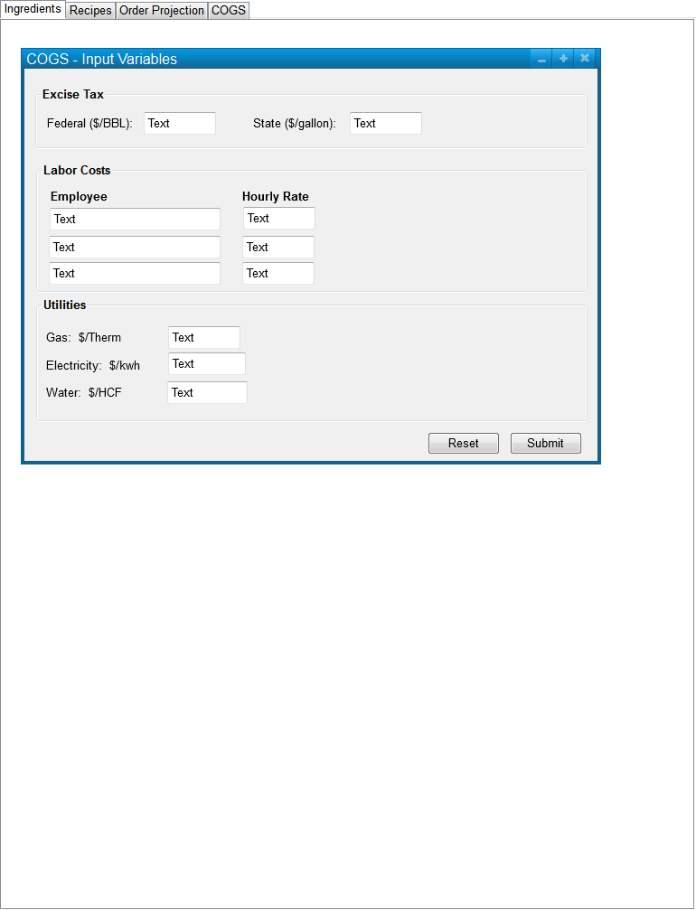

If the user selects Reset, the values are reset to the information in the database file, or to blank if there is no information in the database file.

If the user selects Submit, the information is stored in the database file and the COGS tab contents are updated.

Other Software

<http://www.beerrunsoftware.com/>

Costs (Electricity, Labor hours) are constant for a year, so there is a yearly increase cycle when you enter.

**Market Research Notes**

**1165 Brew Pubs in the US.**